21/02/2017

* Measured the Gear box to produce the 3D model.
* Using Inventor to produce the 3D gear box model.

28/02/2017

* Gain an understanding the functionalities of the Lath.
* Contributing to produce the Gantt chart with Rosani.

7/03/2017

* Acquire the knowledge of the Ball Screw.
* Determine the cost of Ball screw nuts and Ball Screw Shaft through the specific results which are provided from Miguel.

Website: <http://www.thkstore.com/>

Problem:

Unable to identify the exact position of holes on the gear box, because of all the parts that attached to it had not been completely taken off. The critical point is that the match up to the whole assembly of the Lath will be affected if they are not placed correctly.

**Gearbox 3D model**

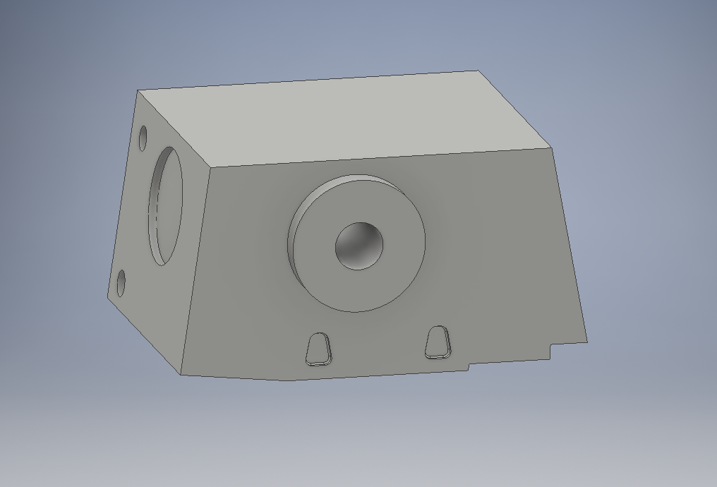

14/03

21/03

-Focusing on documentation to make sure they are up to date.

-Progression report